Guidelines for the use of cost and space saving techniques that can be utilized on poles owned by AT&T

When AT&T is the sole owner of the utility pole, it has authority and exercises rights over the entire pole, including poles covered under joint-use agreements. When AT&T is a joint owner, then it has custodial and administrative rights over the telecommunications space.

DEFINITIONS
- Boxing: This term refers to use of a cross arm or through bolt to facilitate a pole attachment on the opposite side of the pole from an existing attachment and to the installation of facilities on both sides of the same pole at approximately the same height.
- Bracketing: This term refers to the use of an extension arm, cross arm, guard arm, or cable arm hardware that is mounted perpendicular to the pole on top of the existing bolt(s) and extends an attachment horizontally, out from the pole.
- Banding: This is the placement of a metallic band around the circumference of a composition pole that will be used to support attachments.
- Facility: The term used to describe any type of wire or equipment attached to a pole for the purpose of allowing the provisioning of voice, data, and video services.
- Make-ready means any rearrangement of equipment and attachments in order to make room on either an existing pole or a new or different pole for a new attacher.
As a general rule, AT&T does not use boxing or bracketing as techniques to increase conductor or bandwidth capacity of an aerial transmission facility. Typically, facility attachments are vertically layered with an attachment point at each one (1) foot increment in the telecommunications space of a pole. Vertical deployment is the AT&T preferred method of attachment.
Requests to use boxing and bracketing as a cost- and space-saving technique for attaching to AT&T owned poles will be handled through the pole attachment request process.
At all times, generally acceptable engineering guidelines and all applicable safety procedures will be followed.
Boxing will only be considered for AT&T owned poles where there are only attachments in the telecommunications space.
AT&T requires the use of banding as an attachment base for attachments to composite poles, fiberglass reinforced composite poles (FRCP), steel poles, concrete poles, and laminate poles.
When vertical attachment is not practical, AT&T will permit the use of cost- and space-saving techniques (i.e., boxing or bracketing of wood poles or banding of composite poles) where:
- Existing pole(s) have the structural capacity to accept the additional loading;
- Existing pole(s) are sound, serviceable, or
- In locations where use of taller poles is not permitted or restricted.

In all instances of attachment, Anchoring and Guying requirements are to be met (detailed anchor and guy information can be found in the Telcordia Technologies Blue Book, Section 8.
The use of these cost- and space-saving techniques may be considered in, but not necessarily limited to, the following situations:
- Facility transfers that become necessary when a pole placement causes existing attachments in the telecommunications space to be on both sides of the newly placed pole (e.g., a pole with common side vertically layered attachments is defective and the replacement pole is set between two facilities creating a “boxing” condition).
- Placement of a new, nonlinear pole; that is, a pole that is out of line in relation to the existing pole lead, creating a nonlinear condition (e.g., to provide mechanical clearance for a new street or traffic light or an obstruction placed after the original pole lead was erected).
- Municipal restrictions where taller poles for vertical attachment deployment may not be an option (e.g., the local government does not allow poles of varying heights.
The use of these cost-savings techniques will not be considered when:
  - Adequate space exists in the telecommunications space for the placement of additional facilities;
  - The proposed attachment is fundamentally unsafe or otherwise incompatible with generally acceptable engineering purposes and other applicable attachment practices (e.g. if the attachment cannot reasonably accommodate appropriate climbing space).

Example of unacceptable use of boxing
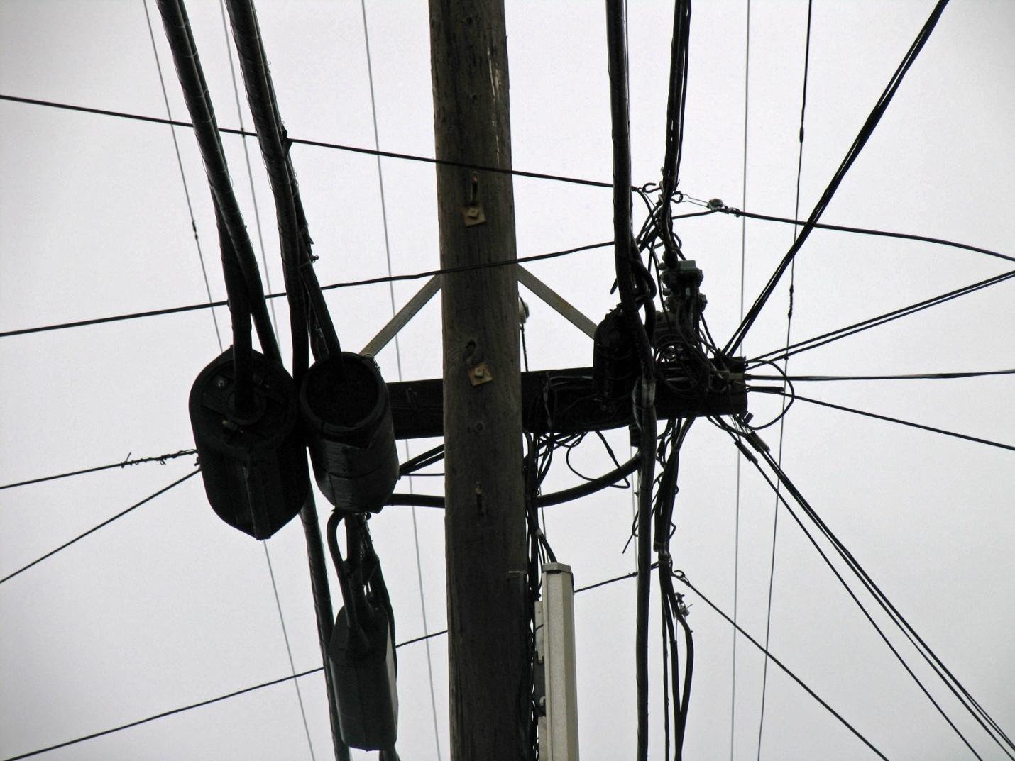

Example of unacceptable use of boxing. 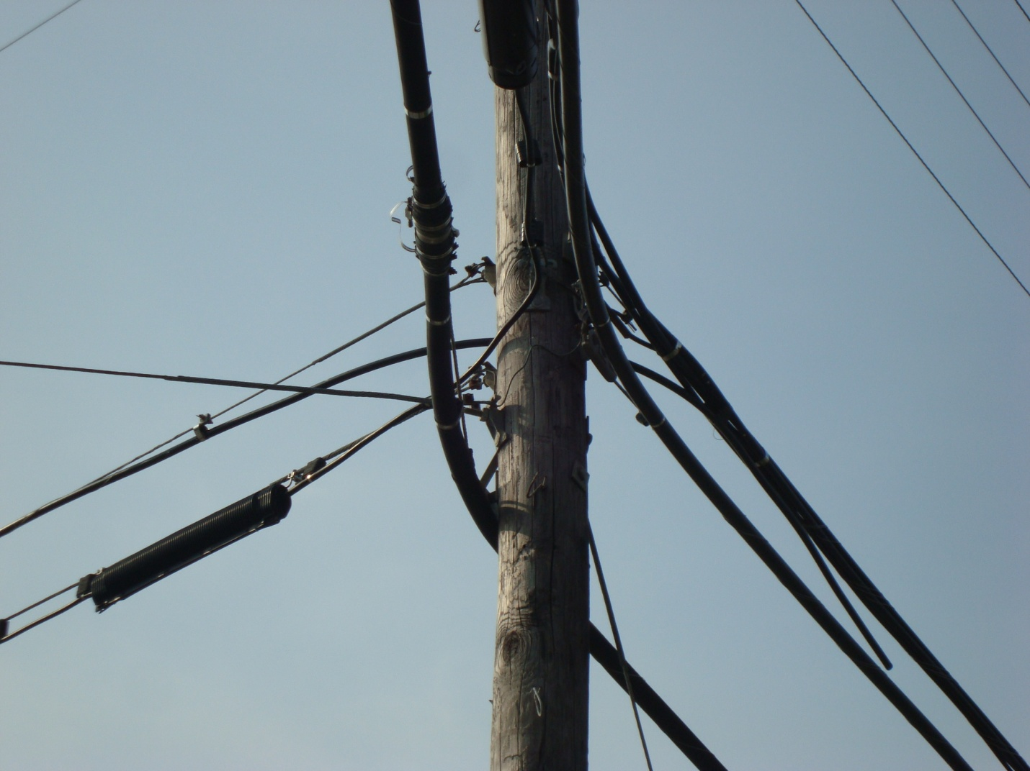

Example of unacceptable boxing. Bracket is placed in the 40” safety zone between the telecommunications and the street light and power space unless permissible by state law:
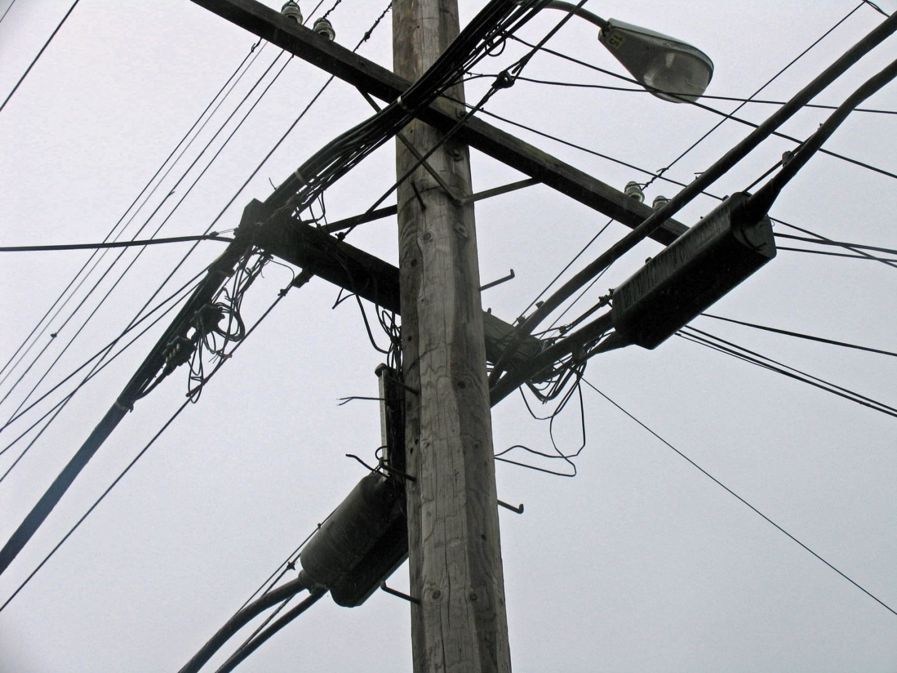

Example of acceptable bracketing:
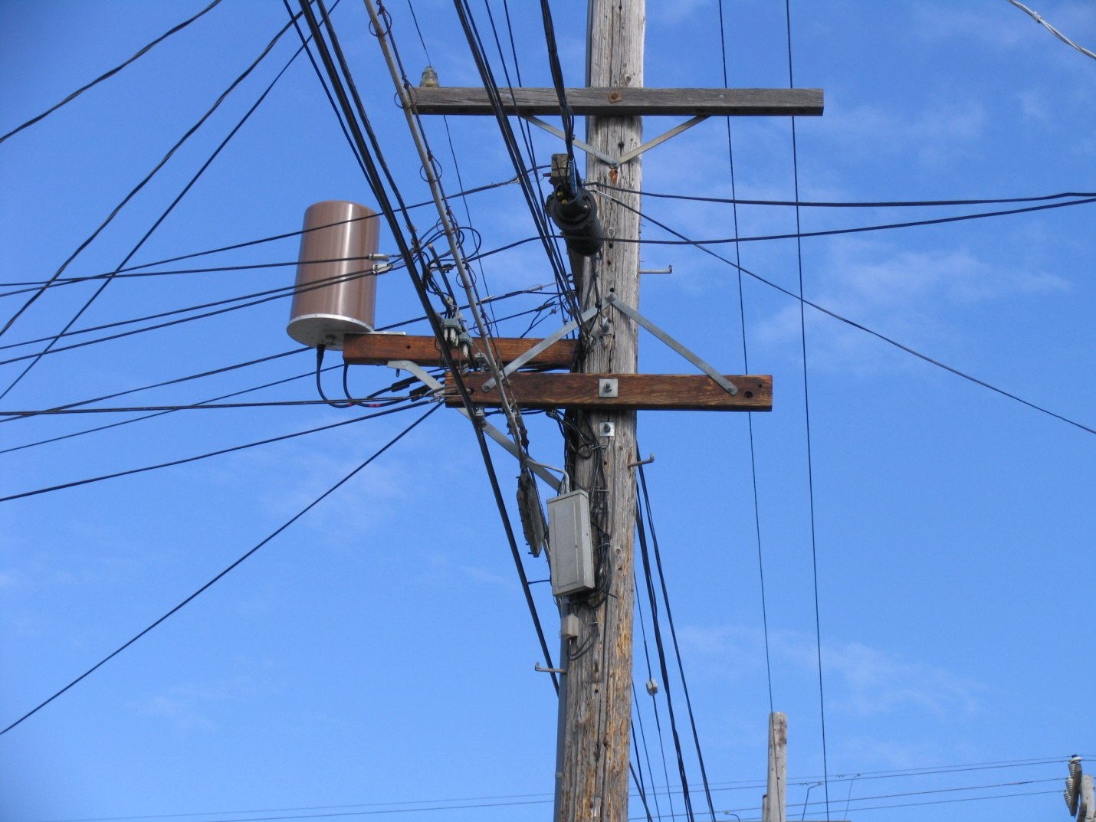

Example of acceptable bracketing:
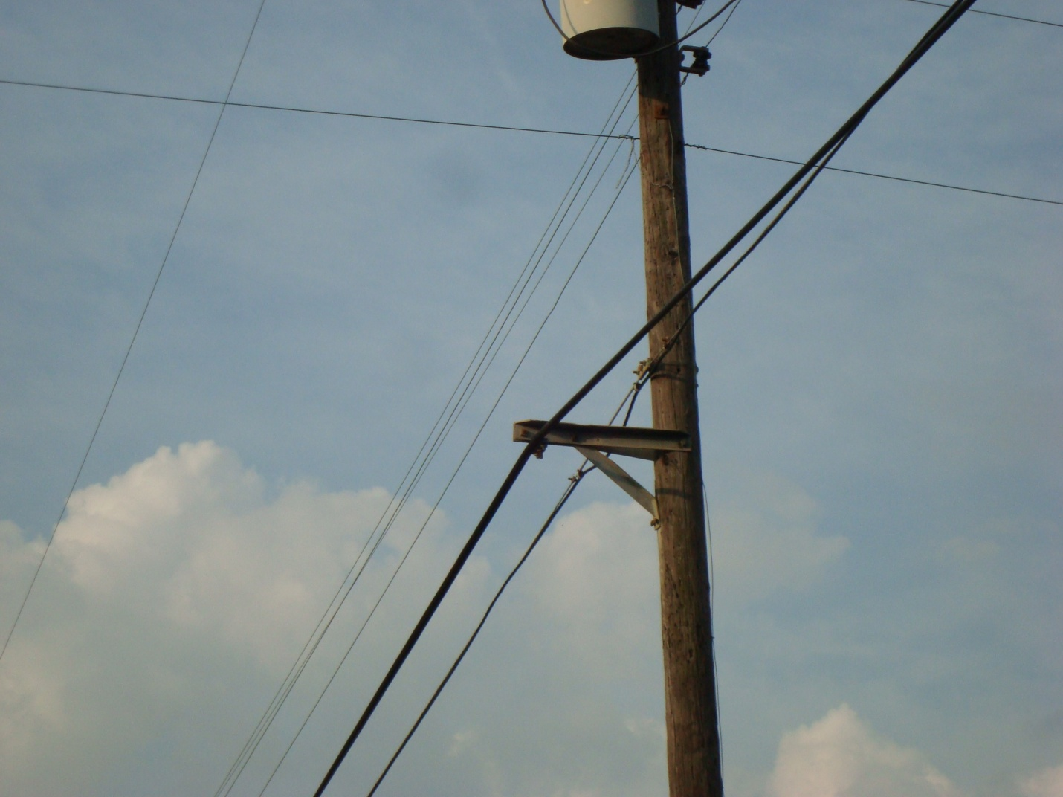

Example of unacceptable bracketing. No 40” safety zone separation between telecommunications space and street light unless permissible by state law.
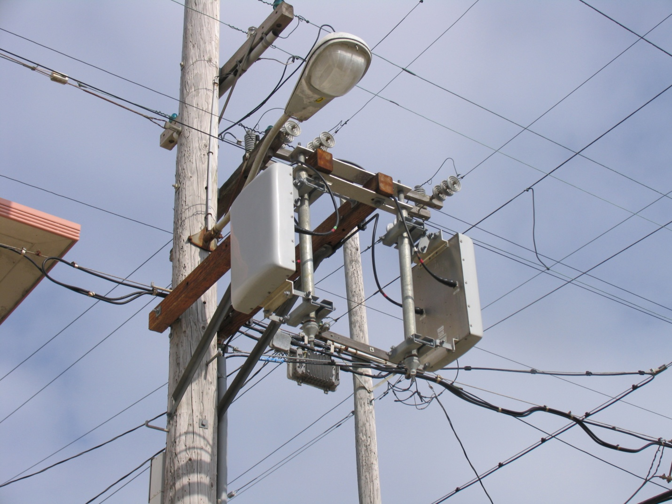

These Guidelines are equally applicable to AT&T incumbent local exchange carriers and all AT&T affiliates, as attachers.
AT&T will accept in good faith, review, and respond to all attachment requests where boxing or bracketing use is expressly requested. AT&T will allow attachers to use the same attachment techniques that AT&T uses under similar circumstances, subject to applicable labor laws and agreements.
AT&T reserves the right to deny a request with respect to any single pole or class of poles for safety, loading, reliability, and generally applicable engineering purposes.
In the event AT&T denies the attachment application for use of space savings techniques for reasons other than those listed herein, AT&T will provide a written explanation to the applicant.
AT&T also reserves the right to amend these Guidelines and to operate under the amended guidelines on a going-forward basis.
This document is publicly available at the Structure Access 21 State Site
PRIMARY POINTS OF CONTACT FOR STRUCTURE ACCESS

(

